AWS Environment Details:

Knowledge Base Created:
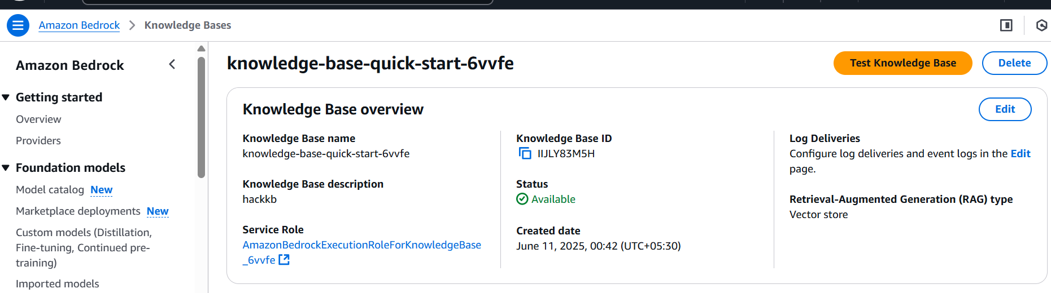

Embedding Model, Vector database and S3 Data source:
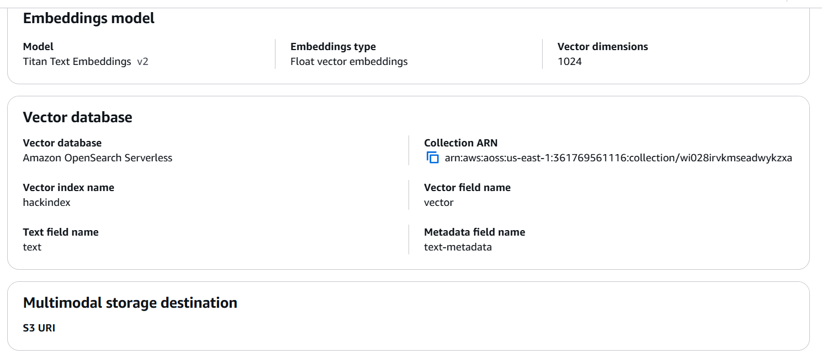

Reviewer Lambda and Event Source:
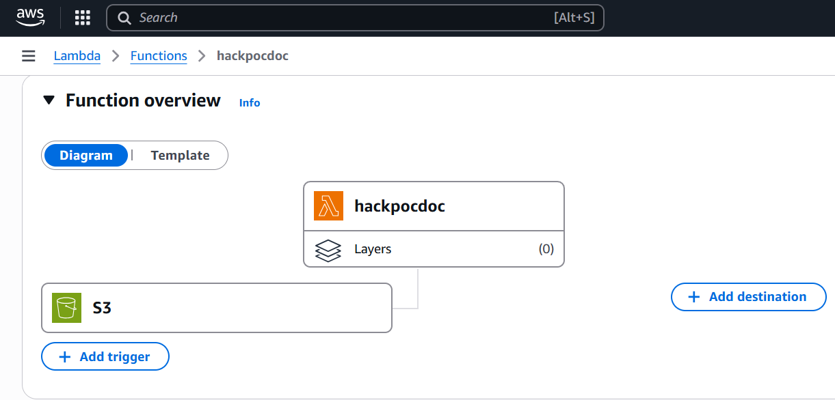

Need to have following access to Models:
- Titan Text Embeddings.
- Claud Sonnet.

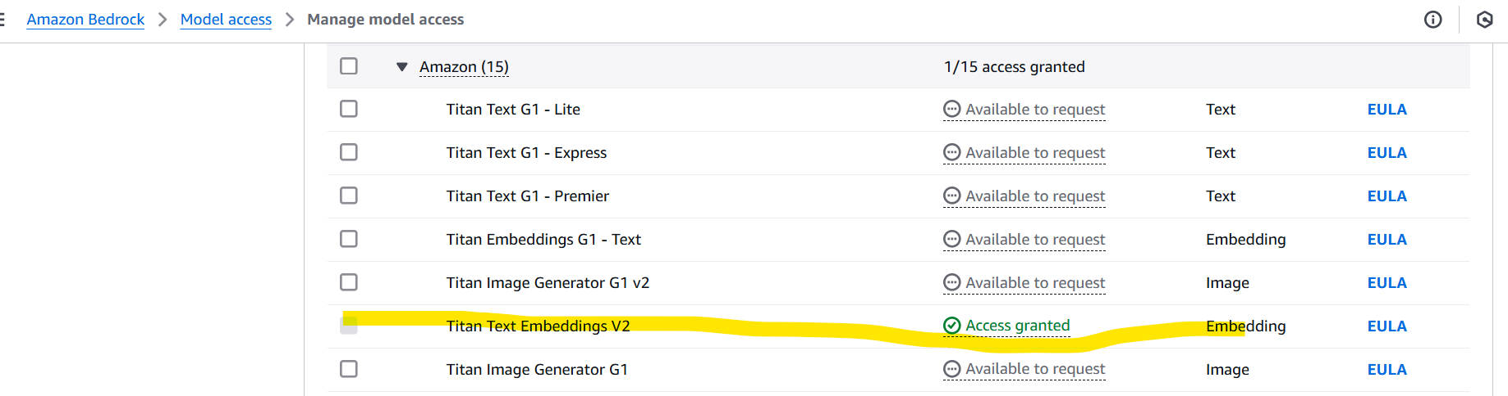

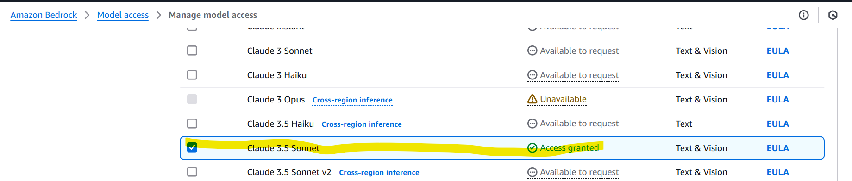

Open Search Service Created with vector search type collection:
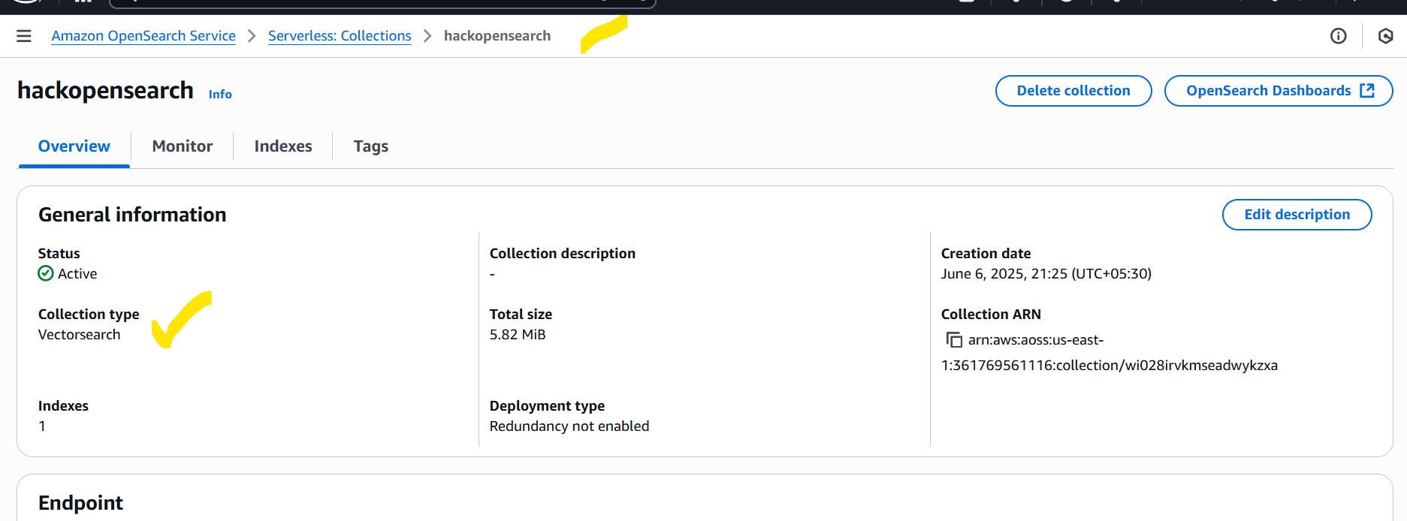

IAM:
IAM roles should be in place for lambda and other services used like Textract to access.

Workloads not implemented:
https://docs.aws.amazon.com/wellarchitected/latest/userguide/workloads.html

